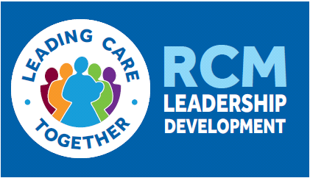

Leading for Maternity Improvement Course for Band 7 Midwives
Application Form

Please complete all sections and sign to agree the terms and conditions
Name
Membership number
Email address
Trust and workplace
Course applied for 2019  (Please delete as appropriate) | London  2 April  13 May  6 June  9 July | Edinburgh  11 September  10 October  6 November  3 December
Please provide a brief outline of the service improvement project that you will work on throughout the course
Name and role of identified mentor from within your Trust/Health Board with whom you will work throughout the course (your mentor may be a senior Midwife within your Unit or an experienced leader from elsewhere within your Trust/Health Board)
Name of Head/Director of Midwifery
As the Head/Director of Midwifery I agree to support the release of the above named person to attend the course.

Terms and Conditions
- I understand I must complete the pre-course work prior to the workshops.

- I have negotiated the required time off to attend the four course workshops.

- I will pay the fee of £250 +vat and this should be received not later than 60 days prior to the first workshop. Written cancellation notice will be required 60 days prior to the first workshop to avoid cancellation charges.

I have read and agree to the terms and conditions
Signature
Name

Date

