Social Media: What you need to know
Speaker Biographies

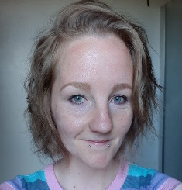
Rosey Adams
Rosey is the founder of PND and Me, perinatal mental health peer support network with weekly Twitter chat #PNDHour every Wednesday 8-9pm, this won an award from MIND in 2016. I experienced Antenatal and Postnatal Depression with all three of my children and I am passionate that all parents deserve access to the right support when they need it. I currently work as an Expert by Experience for NHS Tayside, ensuring that the voices of those with lived experience are heard in the development of the Perinatal and Infant Mental Health Service.

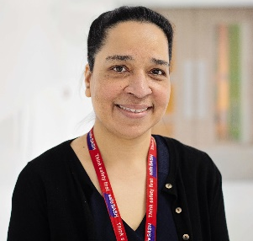
Michelle Cudjoe
Michelle is the Director of Midwifery and Divisional Chief Nurse for Women and Children’s Services at Surrey and Sussex NHS Trust. Michelle has been a Head of Midwifery since 2012 and was appointed as a Director of Midwifery in 2020. Michelle is passionate about patient safety and improving outcomes for all. She is committed to leading with compassion which she believes is a fundamental part of not only patient care but also staff experience. Michelle is proud to be the Director of Midwifery at a maternity service rated as outstanding by the CQC.

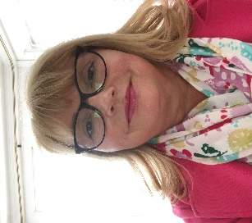
Sally Freeland
I’m currently working for the RCM as a Regional Officer in the Southern Team, covering parts of the South West and South Central area.
Prior to this I worked in the NHS for just shy of 35 years, firstly a nurse at St Georges, London until five years later moving to South Manchester to start my midwifery career . I moved back to my home town in Devon a few years later, to bring up my children. My passion for supporting and being an advocate for my maternity colleagues and all the fabulous people that work within the NHS, lead me to become an RCM Steward and H&S rep. then a Staff Side Chair, prior to my current role.


Sarah Jones
I have been a midwife since 2008 and my current role includes leading, planning and implementing service improvements and workforce developments for effectiveness, safety and sustainability for both women and maternity staff. I have been an RCM steward for 8 years and an RCM Board member from 2019. I have thoroughly enjoyed being an activist for the RCM and went on to win the RCM Members Champion Award for promoting fairness, vision and knowledge to the profession. In recent years I have been particularly interested in being part of the National and international midwifery community on social media, running my own branch page and engaging in midwifery social media discussions on Twitter.


Nimo Mohamud
I am currently a third year student studying the 3-year long course at London South Bank University/. I am half of a BAME focused Instagram page called @atyourcervix that started in May 2020 which is run alongside my friend Amani. I initially entered university studying Criminology (not the most conventional route to Midwifery), however I had always been drawn to healthcare settings, practice and women’s health and had struggled narrow it down one career path when applying for university. I decided after one year of studying criminology (despite how interesting and fun it was) that Midwifery is the chosen career path for me. My experience as a student within the NHS has been absolutely eye-opening and interesting and I’m excited to hopefully be able to call myself a midwife later this year!'

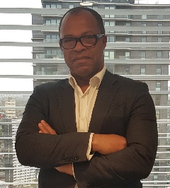
Anthony Robinson
Anthony has been with the NMC for 3 years. Most of his career has been focused on equality, human rights and public law. He is an Assistant Director in Professional Regulation.

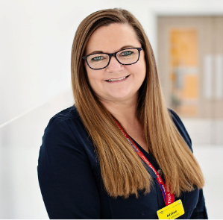
Adaline Smith
Adaline is the Head of Midwifery at Surrey and Sussex NHS Trust. Prior to her appointment as the Head of Midwifery Adaline held a range of senior positions in the Maternity Service. In her role as the Head of Midwifery Adaline is passionate about safe high quality care working in partnership to develop care that is individualised, responsive and kind. Adaline is committed to inclusive leadership and recognises the importance of listening to staff at all levels

