Demystifying the NMC for student midwives
Speaker biographies

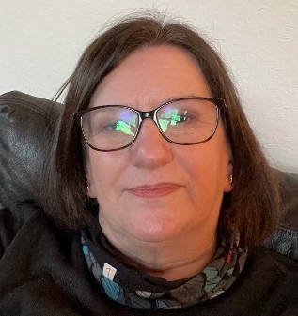
Julia Chandler, Regional Officer, The Royal College of Midwives
Julia trained as a nurse in Preston and as a midwife in Manchester and later moved to Cheltenham to pursue her midwifery career. She practised in all areas of Midwifery as a rotational midwifery sister and joined the RCM in 2004 after 10 years as a steward. Julia has a wide range of experience as an RCM officer, representing members at NMC Interim Order Hearings, negotiating pay nationally, and giving evidence to a Health Select Committee on Perinatal Mental Health. Julia has a post graduate qualification in management studies, and extensive experience of supporting RCM members through NMC processes.


Vicky Richards, National Officer Wales, The Royal College of Midwives
Vicky trained as a Staff Nurse in 1993 and worked on a medical ward within Aneurin Bevan University Health Board prior to commencing her Midwifery training in 1998. She qualified as a midwife in 2000 after taking 6 months off for maternity leave. She then went back to ABUHB to work as a newly qualified midwife before going to Cwm Taf University Health Board ( Now CTMUHB) employed as a midwife. During her time with Cwm Taf Vicky worked in a variety of settings such as ANC, antenatal ward, postnatal ward, Labour ward and lastly managing the maternity day assessment unit. Vicky joined the Royal College of Midwives as Assistant Officer in 2013 and quickly became the National Officer in 2014. Her role now sees her cover Wales and the Channel Islands.

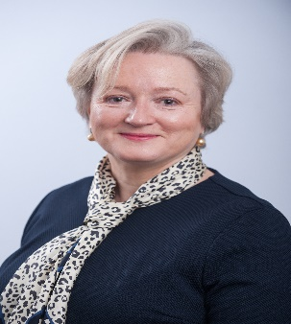
Verena Wallace
Senior Midwifery Adviser (Policy) Nursing and Midwifery Council
Verena was appointed as the NMC’s Senior Midwifery Adviser (Policy) in January 2019. Prior to this, Verena was the Midwifery and Children’s Nursing Officer at the Department of Health in Northern Ireland. She was the Local Supervising Authority Midwifery Officer (LSAMO) in NI for nine years, having previously held senior roles in England as a Deputy Chief Nurse, Head of Midwifery and Consultant Midwife for Public Health. Verena trained as a general nurse in Belfast and has worked as a midwife in Scotland, England and Northern Ireland.

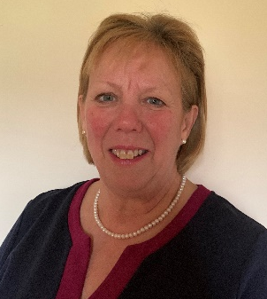
Dr Jacqui Williams MA, BSc(Hons), RM ADM, Dip AppSS.

Senior Midwifery Advisor (Education), Nursing and Midwifery Council.

Jacqui Williams is a very experienced midwifery academic and practising midwife with over 30 years involvement in pre- and post- registration midwifery programmes. As an academic, Jacqui has continued to keep strong links with midwifery practice and is passionate about the unique role of the midwife and women centred care. She is a Senior Fellow with the Higher Education Academy. She has particular area of expertise in quality assurance. Her education interests are in open and distance learning and she has created resources for open access repositories including developing a unique midwifery repository. Jacqui is also an experienced midwifery expert witness. Her doctoral work researched whether resilience develops or not in student midwives as they navigate the undergraduate midwifery programme. Jacqui’s current role is to support the implementation of the new midwifery education standards and the wider work on midwifery matters across the NMC.

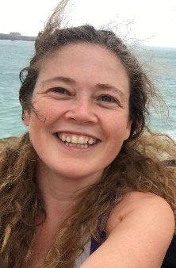
Jo Williams, SMF member
Jo Williams is a final year Student Midwife, training at Harrogate District Hospital, and studying MSc Midwifery at the University of Bradford. She is a mature student, having come to midwifery following a successful corporate career and running her own business. Jo is passionate about advocating for women and has loved every minute of her training. Whilst studying, she has been a student representative for her cohort and a committee member of the university’s Midwifery Society.

